



**Batch: HO – DL 1 Roll No.: 16010422234 Experiment No. 01**

**______________________________________________________________________________**

**Aim:** To understand backpropagation algorithm

**______________________________________________________________________________**

**Resources needed:** Virtual Lab

**______________________________________________________________________________**

**Theory**:

Backpropagation, short for "backward propagation of errors," is an algorithm for supervised learning of artificial neural networks using gradient descent. Given an artificial neural network and an error function, the method calculates the gradient of the error function with respect to the neural network's weights. It is a generalization of the delta rule for perceptrons to multilayer feedforward neural networks. The "backwards" part of the name stems from the fact that calculation of the gradient proceeds backwards through the network, with the gradient of the final layer of weights being calculated first and the gradient of the first layer of weights being calculated last. Partial computations of the gradient from one layer are reused in the computation of the gradient for the previous layer. This backwards flow of the error information allows for efficient computation of the gradient at each layer versus the naive approach of calculating the gradient of each layer separately.

**The algorithm**

Each training iteration of NN has two main stages

1. Forward pass/propagation
2. BP

The BP stage has the following steps:

1. Evaluate error signals for each layer.
2. Use the error signal to compute error gradients.
3. Update layer parameters using the error gradients with an optimization algorithm such as GD.

**How Backpropagation Algorithm Works?**

The Back propagation algorithm in a neural network computes the gradient of the loss function for a single weight by the chain rule. It efficiently computes one layer at a time, unlike a native direct computation. It computes the gradient, but it does not define how the gradient is used. It generalizes the computation in the delta rule.

**______________________________________________________________________________**

**Activity:**

1. Refer the following website:

<https://vlab.spit.ac.in/ai/#/experiments/1>

1. Follow the steps given in the procedure.
2. Run the simulation for
   1. Select any one dataset and type of problem.
   2. Choose the input function of your choice.
   3. Select no of hidden layers and no of hidden neurons.
   4. Select the hyperparameters such as learning rate, epochs, activation function, etc.
   5. Train and test the network.
3. Analyze the effect of regularization on network efficiency.

**______________________________________________________________________________**

**Output:**

Put the screenshots of the network and output.

Attempt post-test questions and put the screenshots in this section.

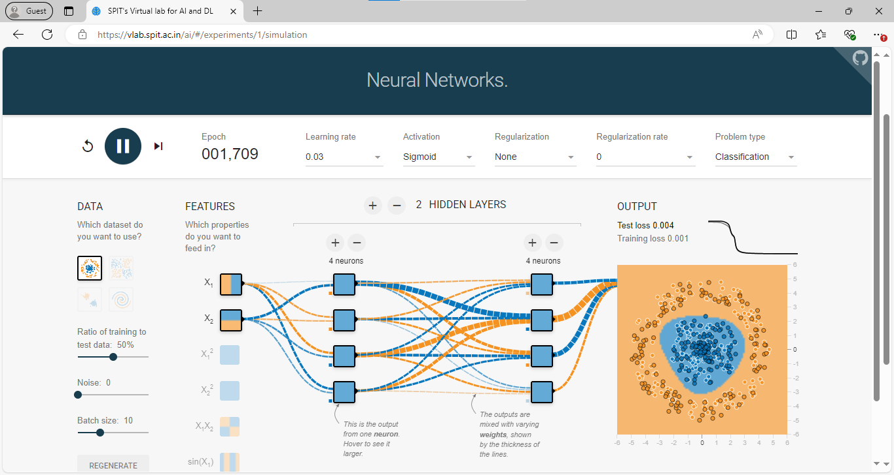

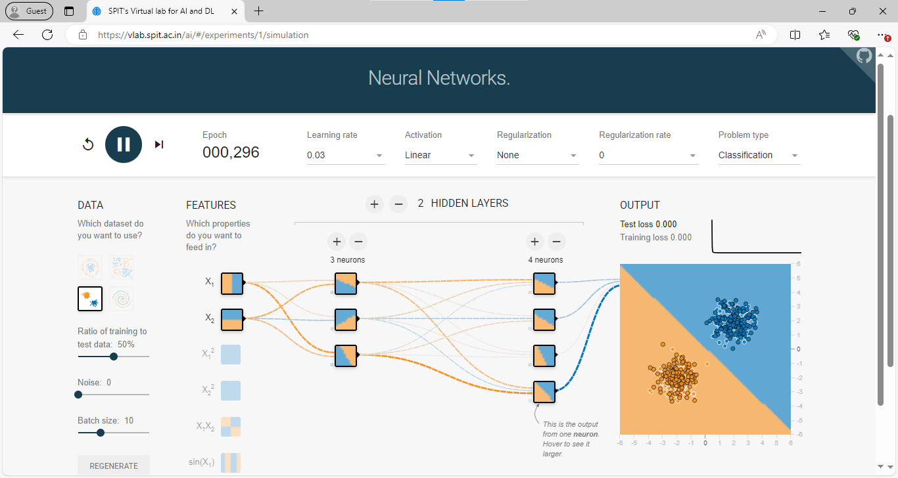

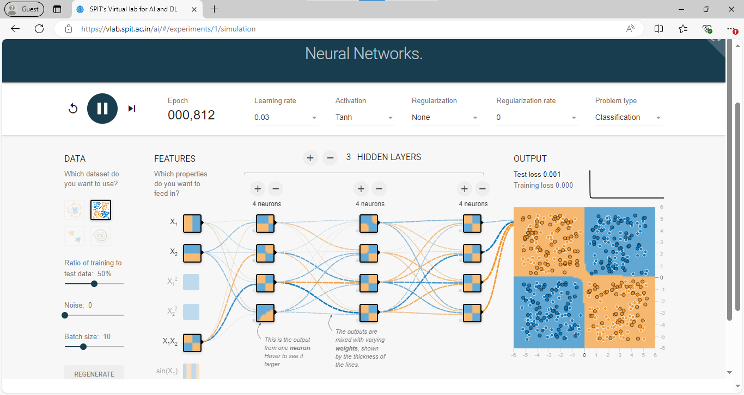

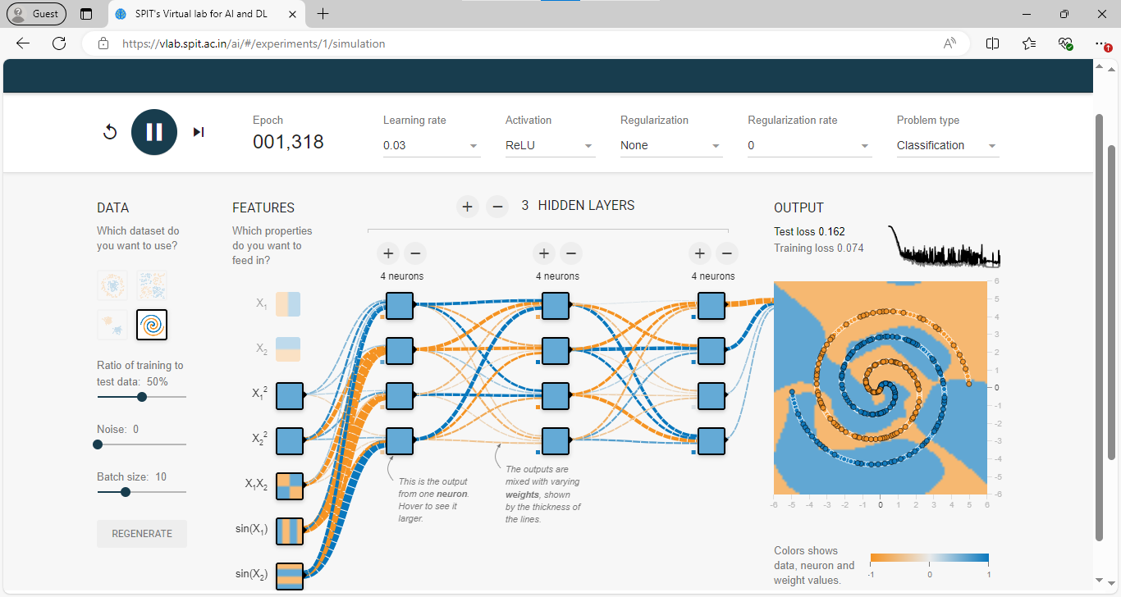

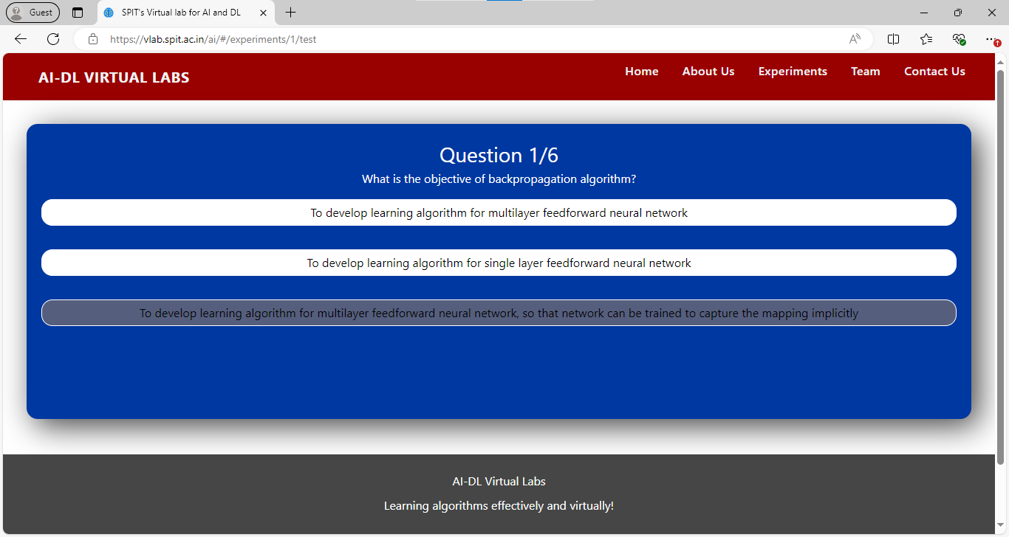

**3. To develop learning algorithm for multilayer feedforward neural network, so that network can be trained to capture the mapping implicitly**

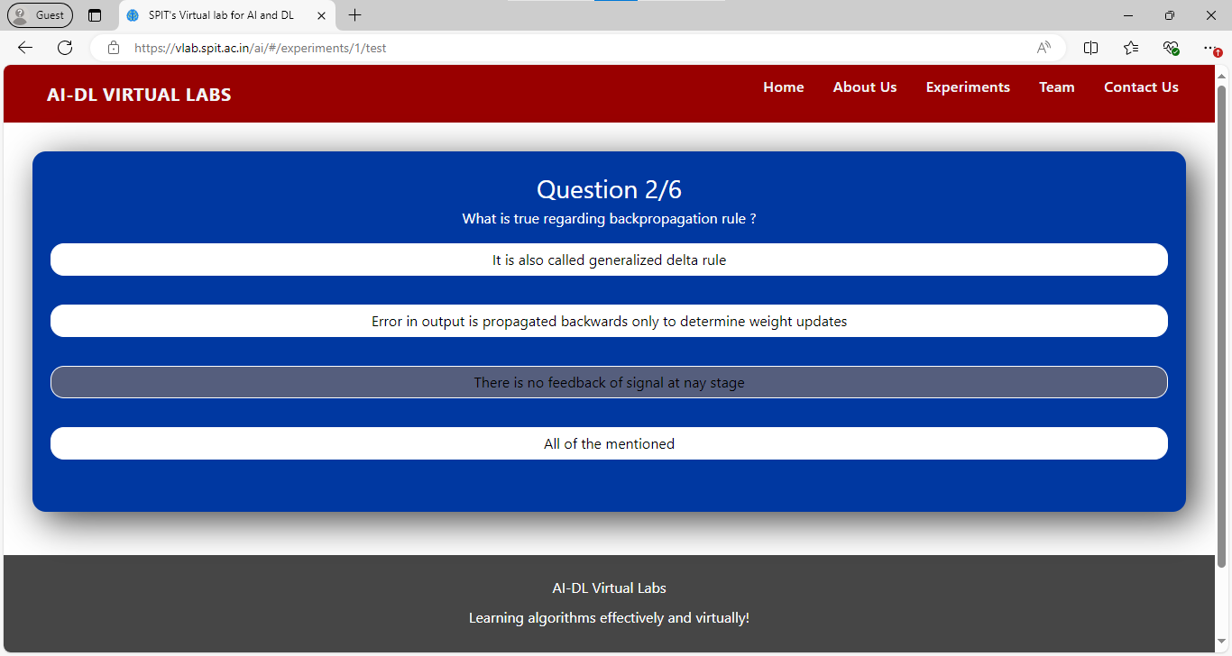

**3. There is no feedback of signal at any stage**

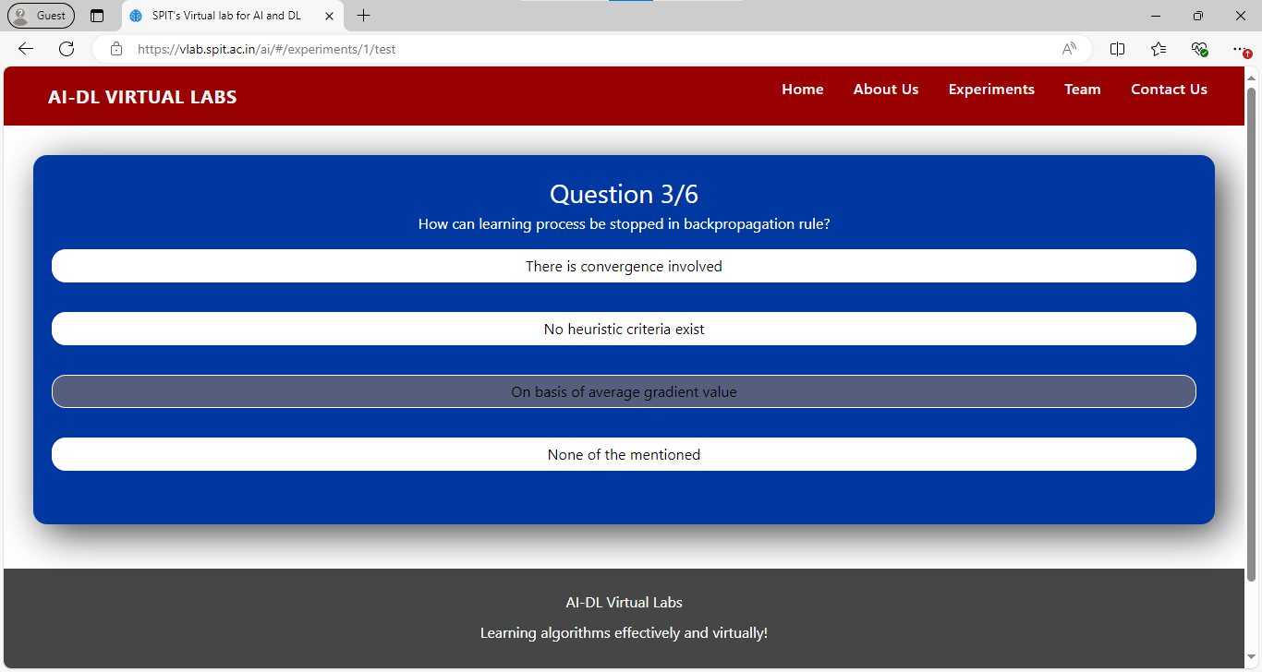

**4. On basis of average gradient value**

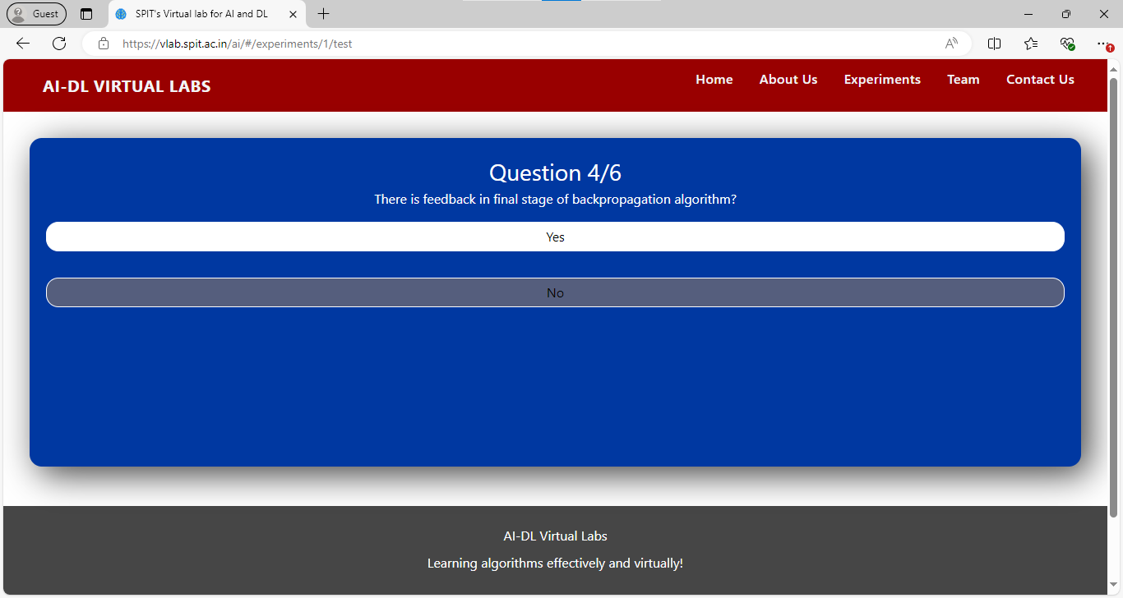

**2. No**

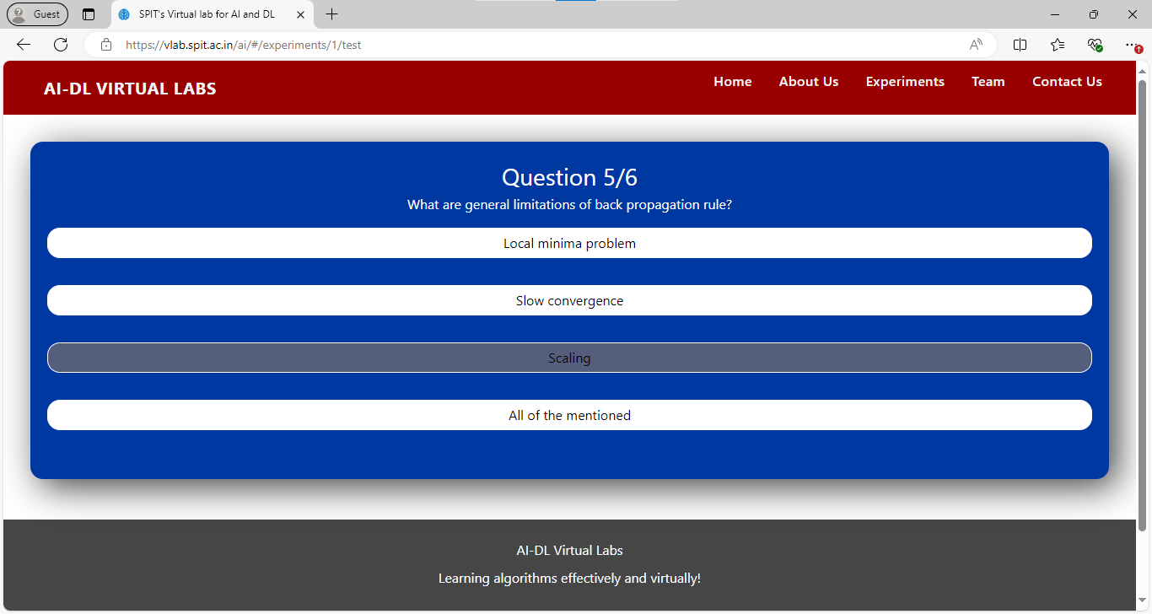

**3. Scaling**

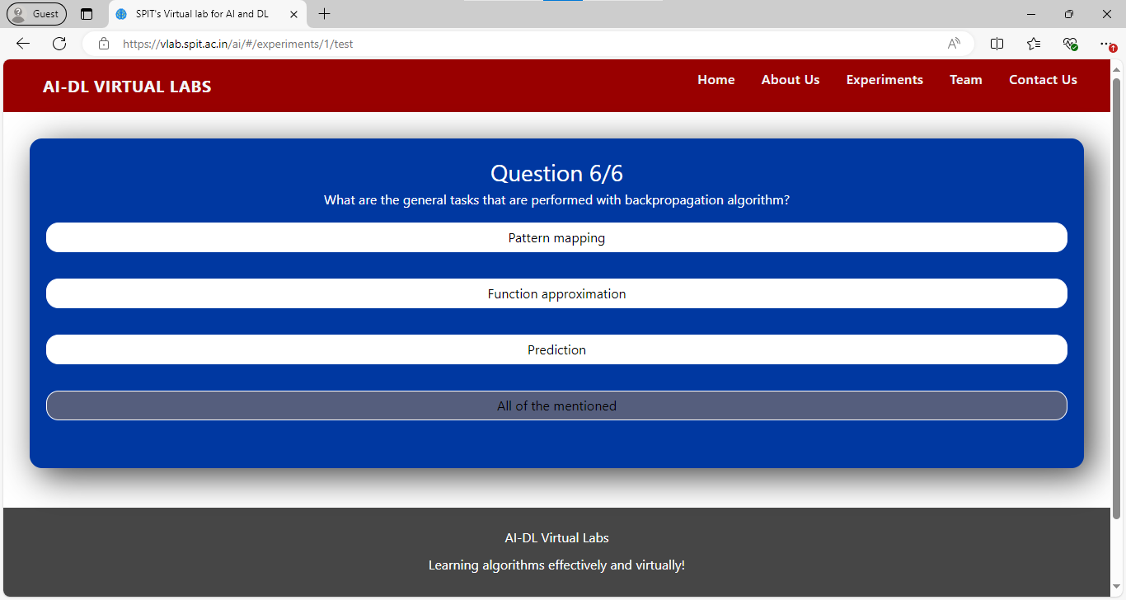

**4. All of the mentioned**

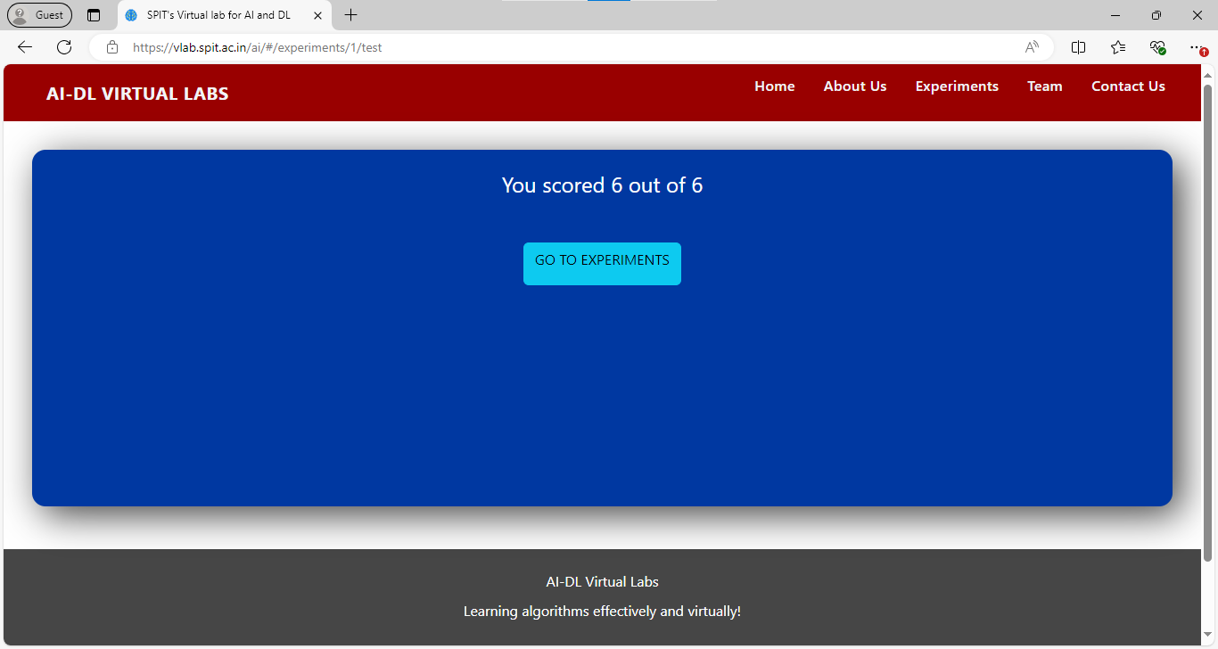

**______________________________________________________________________________**

**Outcome: CO1 – Understand the evolution of Deep Learning.**

**______________________________________________________________________________**

**Conclusion:**

The backpropagation algorithm is a fundamental technique in training artificial neural networks, enabling efficient learning by minimizing the error through gradient descent. By propagating the error backward through the network, it updates the weights systematically, improving the model’s accuracy. The experiment provided hands-on experience in implementing backpropagation, adjusting hyperparameters, and analyzing the impact of regularization on network efficiency. This reinforced the understanding of deep learning principles and the role of optimization techniques in neural network training.

**______________________________________________________________________________**

**Grade: AA / AB / BB / BC / CC / CD / DD**

**Signature of faculty in-charge with date**

**______________________________________________________________________________**

**References:**

**Books/ Journals/ Websites:**

1. Jacek M. Zurada, “Introduction to artificial neural systems”, West Publishing Company
2. <https://vlab.spit.ac.in/ai/#/experiments/1>

**______________________________________________________________________________**